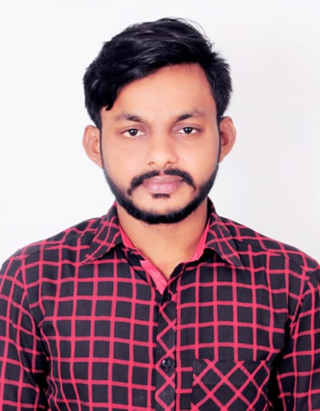

1

© Capgemini 2017. All rights reserved

|

Presentation Title | Author | Date



**Strengths**

**Achievement**

**Education and certificates**

**Base Location:**

**Email ID:**

**Mobile No:**

**Grade:**



**Library Management System**

Completed end to end case study of

Library Management System

System Using SQL and PL/SQL on Oracle 11G

[-](https://sad-bardeen-ceb858.netlify.app/)

[-](https://sad-bardeen-ceb858.netlify.app/)

[/](https://sad-bardeen-ceb858.netlify.app/)

Analyst/Software Engineer

Hyderabad

Syed.khader-basha@capgemini.com

+91

7729815176

•

Software Engineer Who is Strong in design and integration with Intuitive problem-skills. Passionate about implementing and launching new projects

•

Ready to learn new technologies and

implement them to further improve my knowledge.

•

A team player with good communication skill always

ready to work for the enrichment of knowledge.

•

Has working Knowledge on Oracle SQL, PostgreSQL and PL/SQL

Bachelor of Technology

Mechanical Engineering:

-2016-2020

**Skills**

Oracle SQL

Python

HTML ,CSS

**Database**

SQL database

- SQL SERVER

No SQL database

PostgreSQL

–

MongoDB

**Additional Details**

Team Player

Adaptability and quick learner

**Areas of Interest and Hobbies**

Photography

Travelling



**KHADER BASHA SYED**



A4